5th Experiment: Band Structure Simulation for Graphene and CNTs using NanoHub
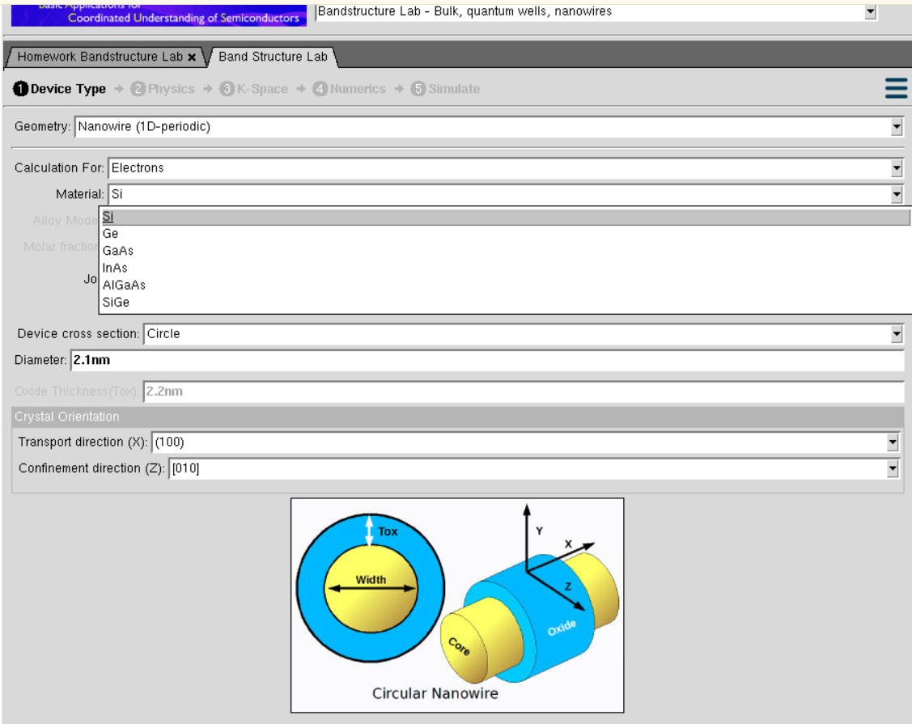

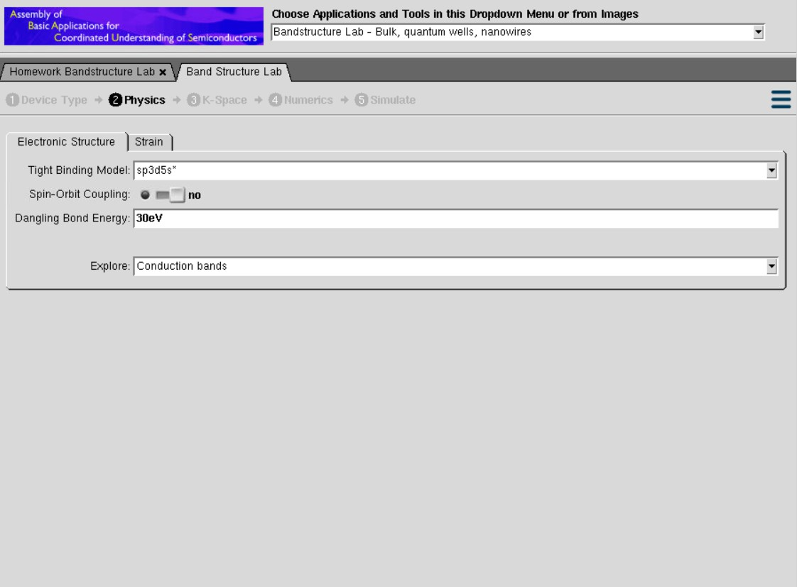

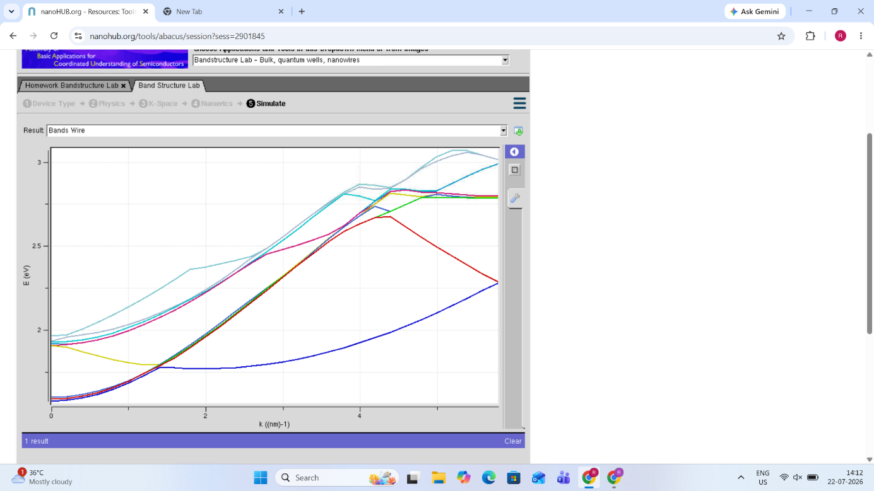
Case Study 1: Simulate the band-structure of InAs circular nanowire
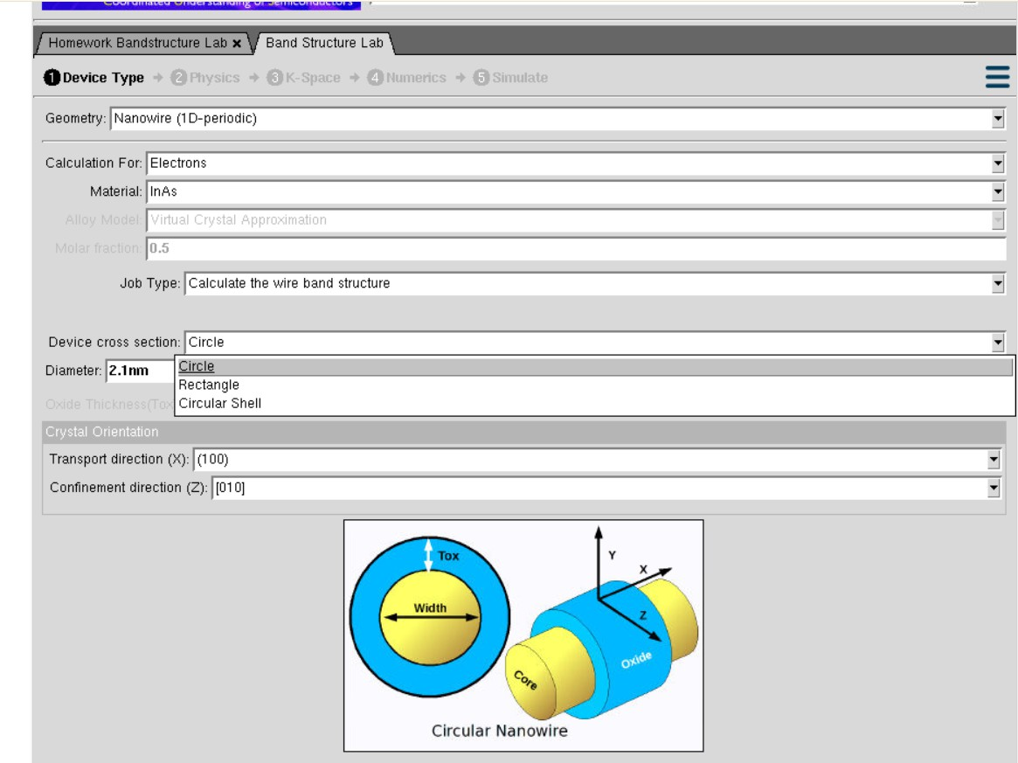

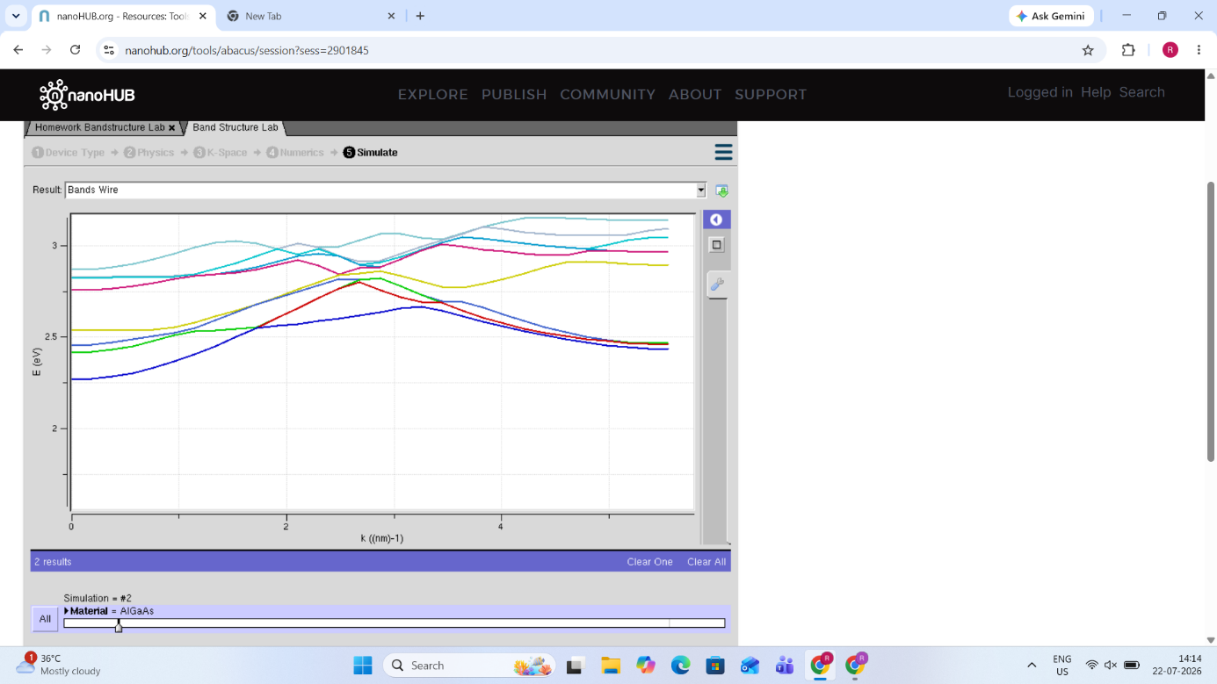
Case Study 2: Simulate the band-structure of AlGaAs circular nanowire

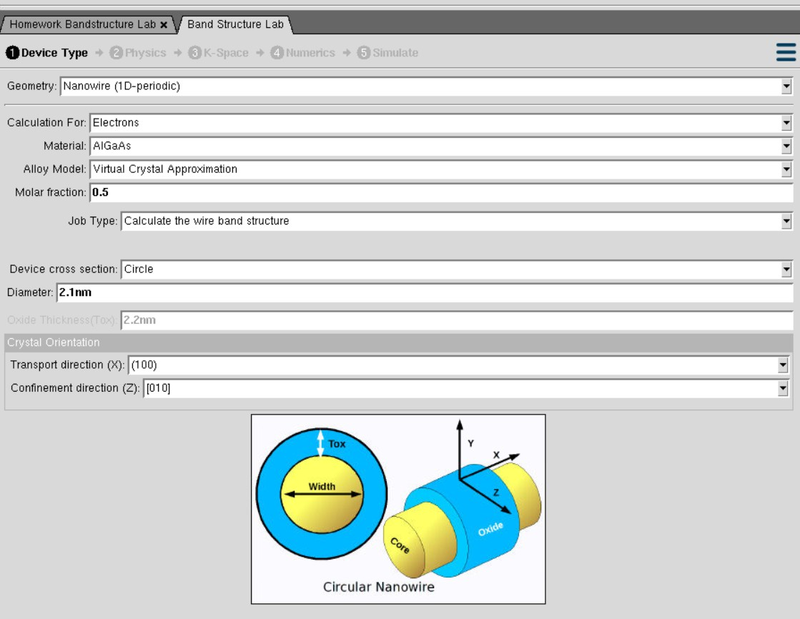

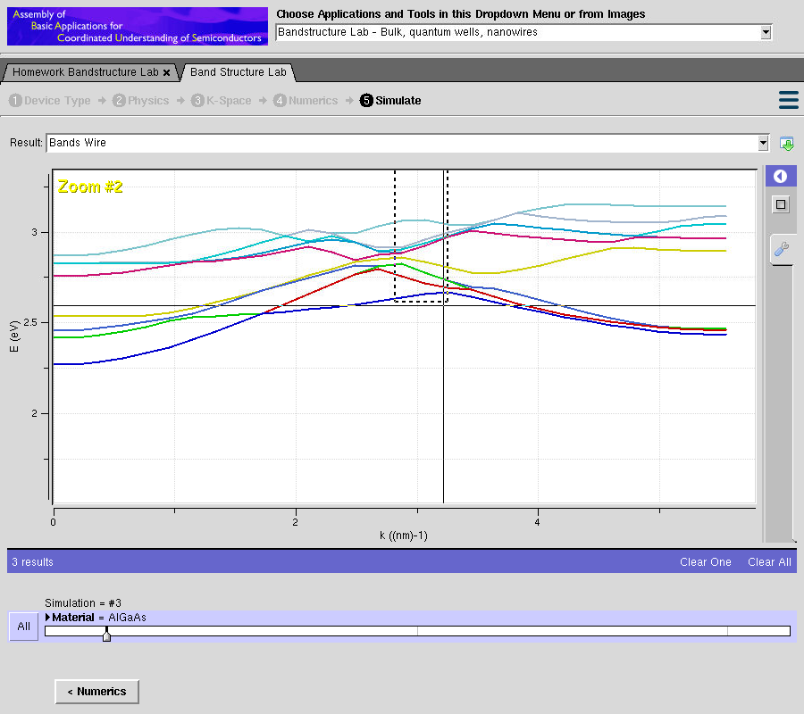
6th Experiment: Demonstration of Quantum Tunneling
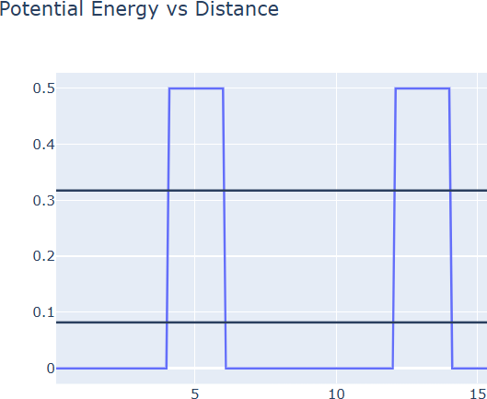

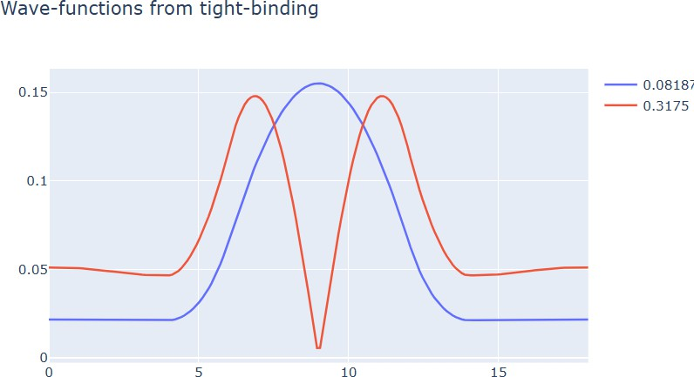

Case Study 1: Analysis the transmission co-efficient Vs Energy characteristics on refined grid

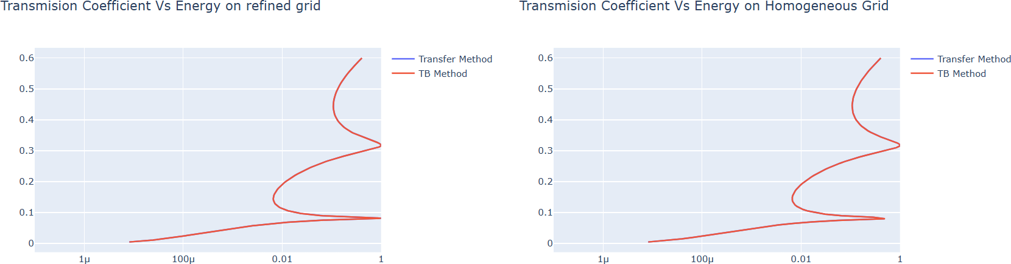

Case Study 2: Analysis the Reflection co-efficient Vs Energy on Homogeneous Grid
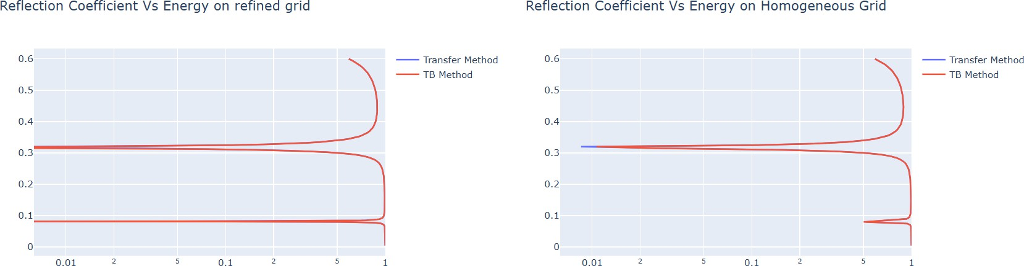

Experiment 7: MOSFET Scaling Analysis and Subthreshold Swing Calculation using NanoHub
